服务器环境配置
所有配置均使用root用户操作完成

资源准备
三台服务器，操作系统为：CentOS release 6.8
IP为别为：
10.0.109.99
10.0.109.100
10.0.109.101

修改主机名
修改三台服务器主机名，修改/etc/sysconfig/network文件
master节点：jttda-master
slave节点1：jttda-slave1
slave节点2：jttda-slave2
每台服务器都修改/etc/hosts文件，添加如下域名映射
10.0.109.99 jttda-master
10.0.109.100 jttda-slave1
10.0.109.101 jttda-slave2

安装JDK

卸载openJDK
查看centos已安装的jdk
rpm –qa | grep gcj
rpm –qa | grep jdk
删除查询到的openJDK相关的安装包
rpm -e –nodeps ***

安装oracle JDK
Oracle官网下载安装包jdk-8u152-linux-x64.tar.gz
将安装包解压到指定目录
tar –zxvf jdk-8u152-linux-x64.tar.gz –C /usr/local/
修改/etc/profile，添加如下配置
export JAVA_HOME=/usr/local/jdk1.8.0_152
export PATH=$PATH:$JAVA_HOME/bin

配置无密码登陆
在master节点上面按照如下顺序执行：
ssh-keygen，一路回车到执行结束
ssh-copy-id root@jttda-slave1，输入yes，回车
ssh-copy-id root@jttda-slave2，输入yes，回车

关闭防火墙
关闭防火墙
service iptables stop
设置开机不启动
chkconfig iptables off

NTP时间同步
设置提供ntp同步的服务器，修改各节点/etc/ntp.conf文件
开启ntp服务
service ntpd start
设置开机启动
chkconfig ntpd on
查看ntp同步状态
ntpstat

Hadoop安装配置

获取安装包
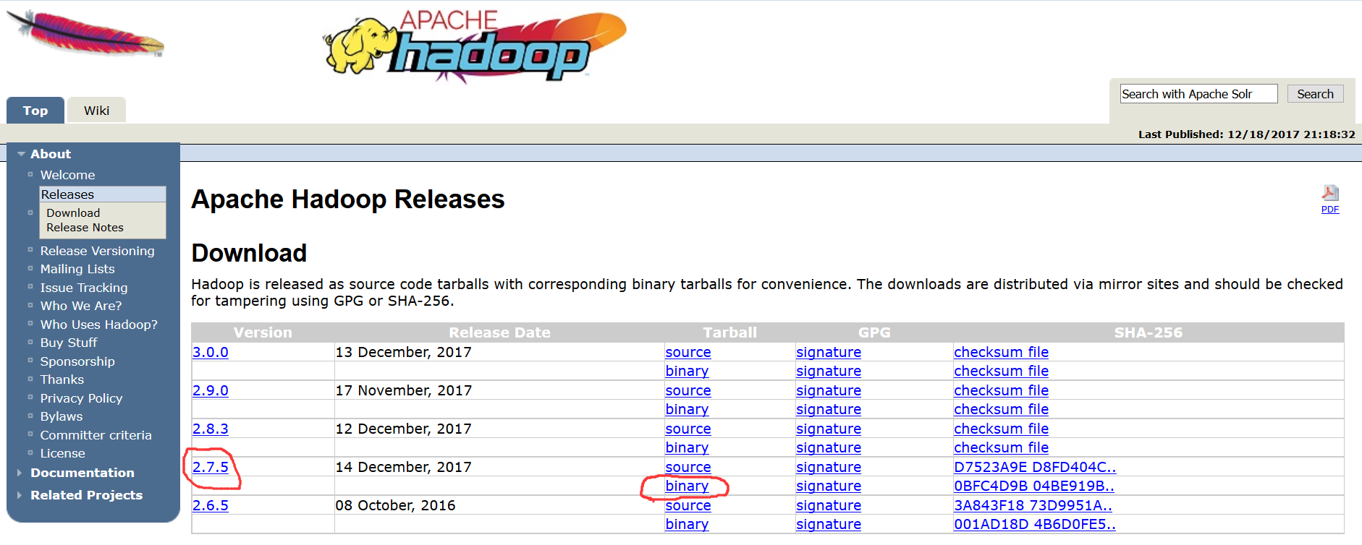
如上图所示，选择所需版本，下载得到压缩包：hadoop-2.7.5.tar.gz
将压缩包解压到选定的目录：tar -zxvf hadoop-2.7.5.tar.gz -C /home/hadoop/install/

设置环境变量
在每个节点的/etc/profile文件中添加如下内容
export HADOOP_HOME=/home/hadoop/install/hadoop-2.7.5
export HADOOP_COMMON_LIB_NATIVE_DIR=$HADOOP_HOME/lib/native
export HADOOP_OPTS="-Djava.library.path=$HADOOP_HOME/lib:$HADOOP_COMMON_LIB_NATIVE_DIR"
export PATH=$PATH:$HADOOP_HOME/bin:$HADOOP_HOME/sbin

创建目录
在每台服务器本地创建目录：
mkdir -p /home/mmds/hadoopdata/dfs/data
mkdir -p /home/mmds/hadoopdata/dfs/name
mkdir -p /home/mmds/hadoopdata/tmp

修改配置文件
进入$HADOOP_HOME/etc/hadoop目录

修改slaves文件
添加DataNode主机名列表，每个主机名一行
jttda-slave1
jttda-slave2

修改core-site.xml文件
<configuration>
<property>
<name>fs.defaultFS</name>
<value>hdfs://jttda-master:9000</value>
</property>
<property>
<name>hadoop.tmp.dir</name>
<value>file:/data/hadoop/tmp</value>
</property>
<property>
<name>io.file.buffer.size</name>
<value>131702</value>
</property>
</configuration>

修改hdfs-site.xml文件
<configuration>
<property>
<name>dfs.namenode.name.dir</name>
<value>file:/data/hadoop/dfs/name</value>
</property>
<property>
<name>dfs.datanode.data.dir</name>
<value>file:/data/hadoop/dfs/data</value>
</property>
<property>
<name>dfs.replication</name>
<value>2</value>
</property>
<property>
<name>dfs.namenode.secondary.http-address</name>
<value>jttda-master:9001</value>
</property>
<property>
<name>dfs.webhdfs.enabled</name>
<value>true</value>
</property>
<property>
<name>dfs.balance.bandwidthPerSec</name>
<value>10485760</value>
</property>
</configuration>

修改mapred-site.xml文件
修改模版文件名
mv mapred-site.xml.template mapred-site.xml
<configuration>
<property>
<name>mapreduce.framework.name</name>
<value>yarn</value>
</property>
<property>
<name>mapreduce.jobhistory.address</name>
<value>jttda-master:10020</value>
</property>
<property>
<name>mapreduce.jobhistory.webapp.address</name>
<value>jttda-master:19888</value>
</property>
<property>
<name>mapreduce.map.memory.mb</name>
<value>2048</value>
</property>
<property>
<name>mapreduce.reduce.memory.mb</name>
<value>2048</value>
</property>
<property>
<name>mapreduce.map.java.opts</name>
<value>-Xmx1536M</value>
</property>
<property>
<name>mapreduce.reduce.java.opts</name>
<value>-Xmx1536M</value>
</property>
<property>
<name>mapred.tasktracker.map.tasks.maximum</name>
<value>8</value>
</property>
<property>
<name>mapred.tasktracker.reduce.tasks.maximum</name>
<value>12</value>
</property>
</configuration>

修改yarn-site.xml文件
<configuration>
<property>
<name>yarn.resourcemanager.hostname</name>
<value>jttda-master</value>
</property>
<property>
<name>yarn.nodemanager.aux-services</name>
<value>mapreduce_shuffle</value>
</property>
<property>
<name>yarn.nodemanager.resource.memory-mb</name>
<value>51200</value>
</property>
<property>
<name>yarn.scheduler.minimum-allocation-mb</name>
<value>2048</value>
</property>
<property>
<name>yarn.scheduler.maximum-allocation-mb</name>
<value>10240</value>
</property>
</configuration>

修改hadoop-env.sh文件
修改如下两个配置项
export JAVA_HOME=/usr/local/jdk1.8.0_152
export HADOOP_HEAPSIZE=2048

修改yarn-env.sh文件
修改如下两个配置项
export JAVA_HOME=/usr/local/jdk1.8.0_152
export YARN_HEAPSIZE=2048
配置完成：
将/usr/local/hadoop-2.7.5整个目录复制到各节点机器上，放在/usr/local/目录下
scp –r /home/hadoop/install/hadoop-2.7.5 jttda-slave50:/home/hadoop/install/hadoop-2.7.5

启动Hadoop
在jttda-master服务器上，进入$HADOOP_HOME目录
格式化NameNode：hdfs namenode -format
启动NameNode和DataNode守护进程：sbin/start-dfs.sh
启动ResourceManager和NodeManager守护进程：sbin/start-yarn.sh

验证Hadoop
执行jps命令，有如下进程，说明Hadoop启动正常
# jps
59024 Jps
153505 ResourceManager
152951 NameNode
156206 RunJar
153247 SecondaryNameNode

Hive安装配置

获取安装包
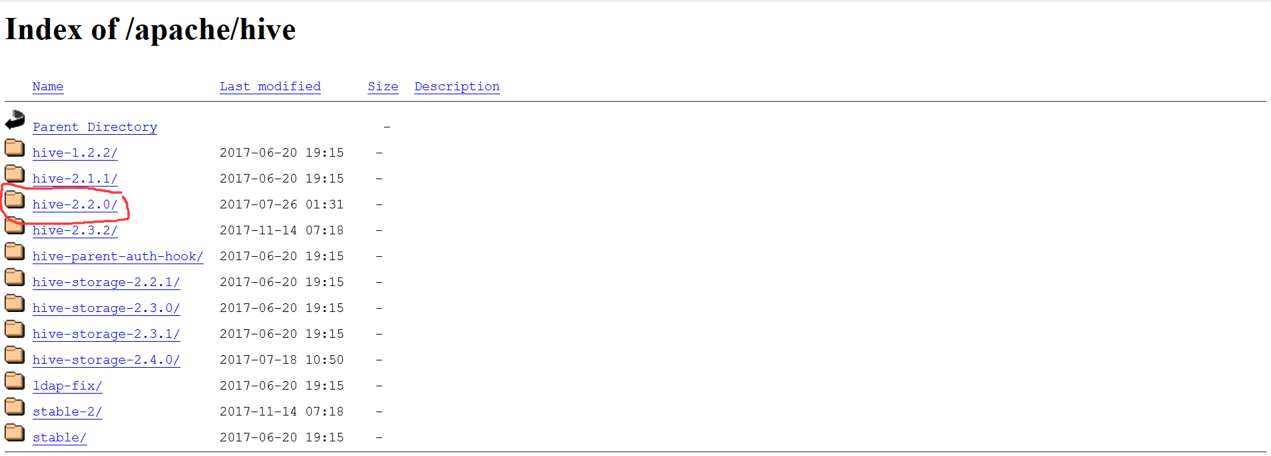
如上图所示，选择所需版本，下载得到压缩包：apache-hive-2.2.0-bin.tar.gz
将压缩包解压到选定的目录：
tar -zxvf apache-hive-2.2.0-bin.tar.gz -C /home/hadoop/install/

设置环境变量
在master节点jttda-master的/etc/profile文件中添加如下内容
export HIVE_HOME=/usr/local/apache-hive-2.2.0-bin
export PATH=$HIVE_HOME/bin:$PATH

创建metastore库
使用Oracle Database 11g作为hive的metastore数据库，创建对应用户并授权
CREATE USER hive IDENTIFIED BY hive;
GRANT SELECT_CATALOG_ROLE TO hive;
GRANT CONNECT, RESOURCE TO hive;
在oracle官网下载JDBC驱动：ojdbc6.jar，将其放到$HIVE_HOME/lib目录下

创建目录
在hdfs 中创建下面的目录 ，并且授权
hdfs dfs -mkdir -p /user/hive/warehouse
hdfs dfs -mkdir -p /user/hive/tmp
hdfs dfs -chmod -R 777 /user/hive/warehouse
hdfs dfs -chmod -R 777 /user/hive/tmp
创建本地目录，进入$HIVE_HOME目录
mkdir log
mkdir execlog
mkdir tmp

修改配置文件
进入$HIVE_HOME/conf目录，复制默认配置文件并改名
cp hive-env.sh.template hive-env.sh
cp hive-default.xml.template hive-site.xml
cp hive-log4j2.properties.template hive-log4j2.properties
cp hive-exec-log4j2.properties.template hive-exec-log4j2.properties

修改hive-env.sh文件
修改以下配置项
export JAVA_HOME=/usr/local/jdk1.8.0_152
export HADOOP_HOME=/usr/local/hadoop-2.7.5
export HIVE_HOME=/usr/local/apache-hive-2.2.0-bin
export HIVE_CONF_DIR=/usr/local/apache-hive-2.2.0-bin/conf

修改hive-site.xml文件
<configuration>
<property>
<name>hive.exec.scratchdir</name>
<value>/user/hive/tmp</value>
</property>
<property>
<name>hive.metastore.warehouse.dir</name>
<value>/user/hive/warehouse</value>
</property>
<property>
<name>hive.querylog.location</name>
<value>/usr/local/apache-hive-2.2.0-bin/tmp/${user.name}</value>
</property>
<property>
<name>javax.jdo.option.ConnectionURL</name>
<value>jdbc:oracle:thin:@10.0.109.8:1521:sjzx8</value>
</property>
<property>
<name>javax.jdo.option.ConnectionDriverName</name>
<value>oracle.jdbc.driver.OracleDriver</value>
</property>
<property>
<name>javax.jdo.option.ConnectionUserName</name>
<value>hive</value>
</property>
<property>
<name>javax.jdo.option.ConnectionPassword</name>
<value>hive</value>
</property>
</configuration>
并在hive-site.xml中
所有${system:java.io.tmpdir}替换为/usr/local/apache-hive-2.2.0-bin/tmp/
所有{system:user.name}替换为{user.name}

修改hive-log4j2.properties文件
property.hive.log.dir = /usr/local/apache-hive-2.2.0-bin/log/${sys:user.name}

修改hive-exec-log4j2.properties文件
property.hive.log.dir = /usr/local/apache-hive-2.2.0-bin/execlog/${sys:user.name}

修改core-site.xml文件
进入$HADOOP_HOME/etc/hadoop目录给beeline登录时的用户root配置权限，增加如下的配置项
<configuration>
<property>
<name>hadoop.proxyuser.root.groups</name>
<value>root</value>
</property>
<property>
<name>hadoop.proxyuser.root.hosts</name>
<value>*</value>
</property>
</configuration>

启动Hive

初始化
schematool -dbType mysql -initSchema

CLI启动Hive
在命令行输入命令：hive

使用beeline
启动hiveserver2：nohup hive --service hiveserver2 >/dev/null 2>&1 &
查看hiveserver2启动状态：netstat -nptl | grep 10000
启动beeline
在命令行输入命令：beeline
连接Hive：!connect jdbc:hive2://localhost:10000 root root

Tez安装配置

获取安装包
如上图所示，选择所需版本，下载得到压缩包：apache-tez-0.9.0-bin.tar.gz
将压缩包解压到选定的目录：
tar –zxvf apache- tez-0.9.0-bin.tar.gz –C /usr/local/

上传运行包
在apache-tez-0.9.0-bin/share下有个tez.tar.gz压缩包，把它上传到hdfs上面
hadoop fs -mkdir -p /user/tez
hadoop fs -put tez.tar.gz /user/tez

修改配置文件
进入$HADOOP_HOME/etc/hadoop目录

新建tez-site.xml文件
<configuration>
<property>
<name>tez.lib.uris</name>
<value>/user/tez/tez.tar.gz</value>
</property>
</configuration>

修改mapred-site.xml文件
<configuration>
<property>
<name>mapreduce.framework.name</name>
<value>yarn-tez</value>
</property>
</configuration

修改hadoop-env.sh文件
export TEZ_HOME=/usr/local/apache-tez-0.9.0-bin
for jar in `ls $TEZ_HOME |grep jar`; do
export HADOOP_CLASSPATH=$HADOOP_CLASSPATH:$TEZ_HOME/$jar
done
for jar in `ls $TEZ_HOME/lib`; do
export HADOOP_CLASSPATH=$HADOOP_CLASSPATH:$TEZ_HOME/lib/$jar
done

测试Tez
在hdfs上创建/tinput和/toutput目录
准备测试文件
echo "Hello World Hello Tez" > file01
echo "Hello World Goodbye Tez" > file02
将测试文件file01和file02上传到hdfs上的/tinput目录
hdfs dfs -mkdir /tinput
hdfs dfs -put file0* /tinput
执行如下命令测试tez是否配置成功，进去$TEZ_HOME目录
hadoop jar tez-examples-0.9.0.jar orderedwordcount /tinput /toutput

测试用例

备注
将$HIVE_HOME/lib/log4j-slf4j-impl-2.6.2.jar和$TEZ_HOME/lib/slf4j-log4j12-1.7.10.jar删除，否则会与$HADOOP_HOME/LIB/slf4j-log4j12-1.7.10.jar重复

